1. Create a box using vagrant with centos 7
2. Centos 7: change the /etc/sshd/sshd_config file to PasswordAuthentication to yes and reboot or restart the sshd service.
3. Installation of Docker

Using Repository:

SET UP THE REPOSITORY

1. Install required packages. yum-utils provides the yum-config-manager utility, and device-mapper-persistent-data and lvm2 are required by the devicemapper storage driver.

# yum install -y yum-utils device-mapper-persistent-data lvm2

Use the following command to set up the **stable** repository.

$ yum-config-manager --add-repo https://download.docker.com/linux/centos/docker-ce.repo

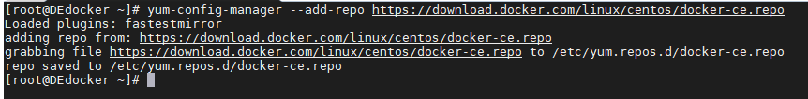

Install Docker:

Execute the following command to install docker:

# yum install docker-ce.x86_64-3:18.09.9-3.el7 docker-ce-cli.x86_64-1:18.09.9-3.el7 containerd.io -y

# yum install docker

Start Docker:

# systemctl start docker

Verify that Docker Engine - Community is installed correctly by running the hello-world image.

$ docker run hello-world

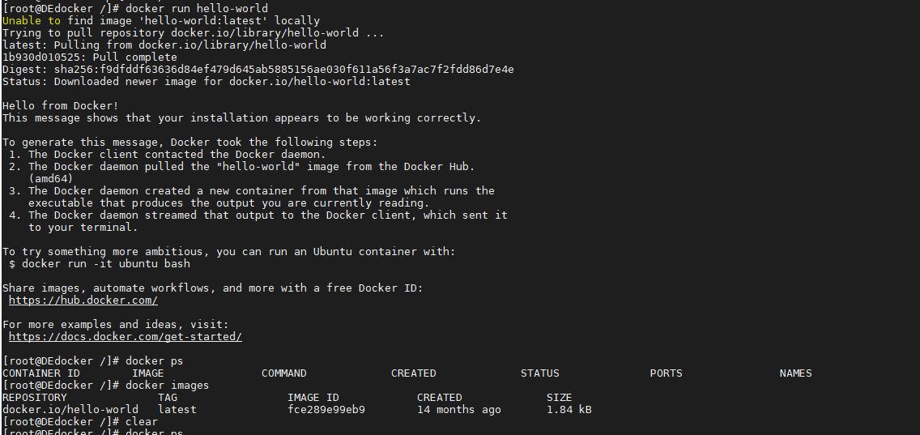

Create a docker file:

FROM nginx:alpine

MAINTAINER Subhasish G <subhatcloud@gmail.com>

COPY website /website

COPY nginx.conf /etc/nginx/nginx.conf

EXPOSE 80:80

Install docker compose:

Run this command to download the current stable release of Docker Compose:

curl -L "https://github.com/docker/compose/releases/download/1.25.4/docker-compose-$(uname -s)-$(uname -m)" -o /usr/

Apply executable permissions to the binary:

chmod +x /usr/local/bin/docker-compose

[root@DEdocker docker]# docker-compose version

docker-compose version 1.25.4, build 8d51620a

docker-py version: 4.1.0

CPython version: 3.7.5

OpenSSL version: OpenSSL 1.1.0l 10 Sep 2019

[root@DEdocker docker]#

Create docker-compose.yml file:

version: '3.7'

services:

website:

build:

context: .

ports:

- 80:80

Run the following command to build from docker compose:

docker-compose run website

docker-compose up

**Website should be up and running now.**

Testing Your App with RSpec, Capybara and Selenium:

RSPEC – Ruby based testing framework. (Domain specific language)

Capybara – Tool like web driver, test buttons. (can run java script)

Selenium – real testing can test CSS.

Create mkdir spec/unit

yum install docker-ce.x86_64-3:18.09.9-3.el7 docker-ce-cli.x86_64-1:18.09.9-3.el7 containerd.io -y